Adrien Protzel

1. 1. r = (01*(01)*) + (11*0)
   2. 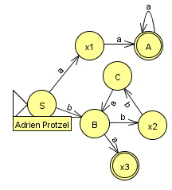

| q0 -> 0q1 |
| --- |
| q0 -> 1q3 |
| q1 -> 1q1 |
| q1 -> 0q2 |
| q1 -> 1q1 |
| q3 -> 1q3 |
| q3 -> 0q4 |
| q1 -> λ |
| q4 -> λ |

1. 2. r = (aaa*) + (b(bba)*a)
2. k = {a+b+c+d+e} n = {1+2+3}

r = k(k+n)(k+n)(k+n) (k+n)* nn

1. L consists of {a1, a2, a3, …, an} and an NFA that accepts L has start state S and accepting state A with ai number of states between S and A. Where the machine can only accept a string of aiai.